Kitsap 23RD Annual County Human Rights Conference
The Ally is YOU!
December 6, 2013 8 a.m. - 3 p.m. Kitsap Conference Center, Bremerton
A day of speakers, workshops and networking—bringing people together to educate and strengthen our
Lesbian, Gay, Bisexual, Transgender, Questioning and Intersex communities and Allies
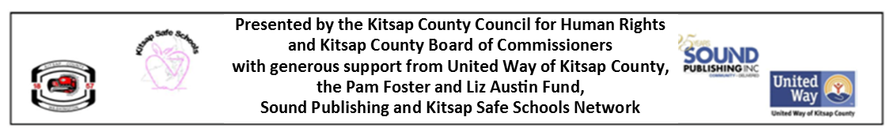
HIGH SCHOOL & COLLEGE STUDENT TICKETS:
Thanks to generous grants from the Pam Foster and Liz Austin Fund and the Kitsap Safe Schools Network, a number of full scholarships are available for high school and college students (middle school students may also be eligible).

To register students from your school for scholarships, please complete the information below and send to kitsapsafeschools@gmail.com . You also may register one adult who will accompany your students for a scholarship.

Registration deadline is November 30. The conference will not be cancelled because of inclement weather.

Student Scholarship Registration Form

Your Name: School:

School group/program:

Address: Phone:

City State Zip: E-mail:

Adult companying students:

# Student scholarships requested:

For more information, contact Kitsap Safe Schools at 800-503-7615 or e-mail kitsapsafeschools@gmail.com

